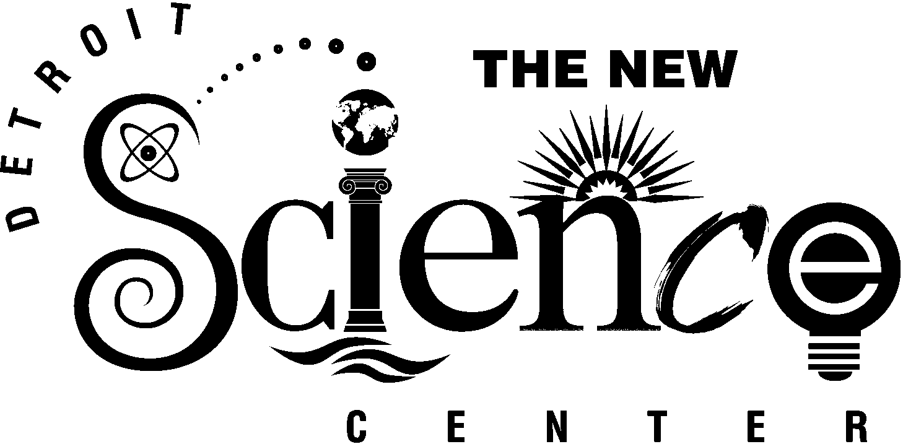

Rave Reviews From Our Clients

“Thank you for making our experience at The New Detroit Science Center so special! Your efforts and the Science Center facility set a new benchmark for our group events.”
Paul Wagner
Vice President, Human Resources and Intellectual Capital Services
MSX International

“It was a pleasure working with you on the first-ever First Man’s Forum Inaugural event with
Dan Mulhern. The event was a huge success!”
Iana Dealey
Associate/PR Director
Brogan & Partners Convergence Marketing

“My experience working with the Science Center events team was nothing but wonderful. It was great working with such detail-oriented and hard-working individuals. Everything ran smoothly. I want to extend my sincere gratitude for making my job 100% easier. Who could ask for more?”
Christine Robison
Program Specialist
OHEP Center for Medical Education

“Thank you for helping us to put on such a successful event at The New Detroit Science Center. I have received nothing but rave reviews about the facility from our attendees and sponsors.

From the perspective of an events planner working behind the scenes, I must tell you how incredibly helpful, courteous, and professional your staff was. I could not have made this event happen without their constant assistance. As an events planner I work with many venues throughout the year, and it is rare that I come across such an enthusiastic and professional staff.

The Science Center truly stands out as a first class venue, and I will be sure to recommend it to other event planners in the future.”
Jessica Schlick
Events Director
Digital Detroit

“Thank you for your help in making our seminar the success it was. I appreciate the help, the professionalism, and the use of such a top-notch facility. Everyone seemed to enjoy the evening!”
Allan Tobin
Assistant Vice President, Private Banking Division
Comerica Bank

