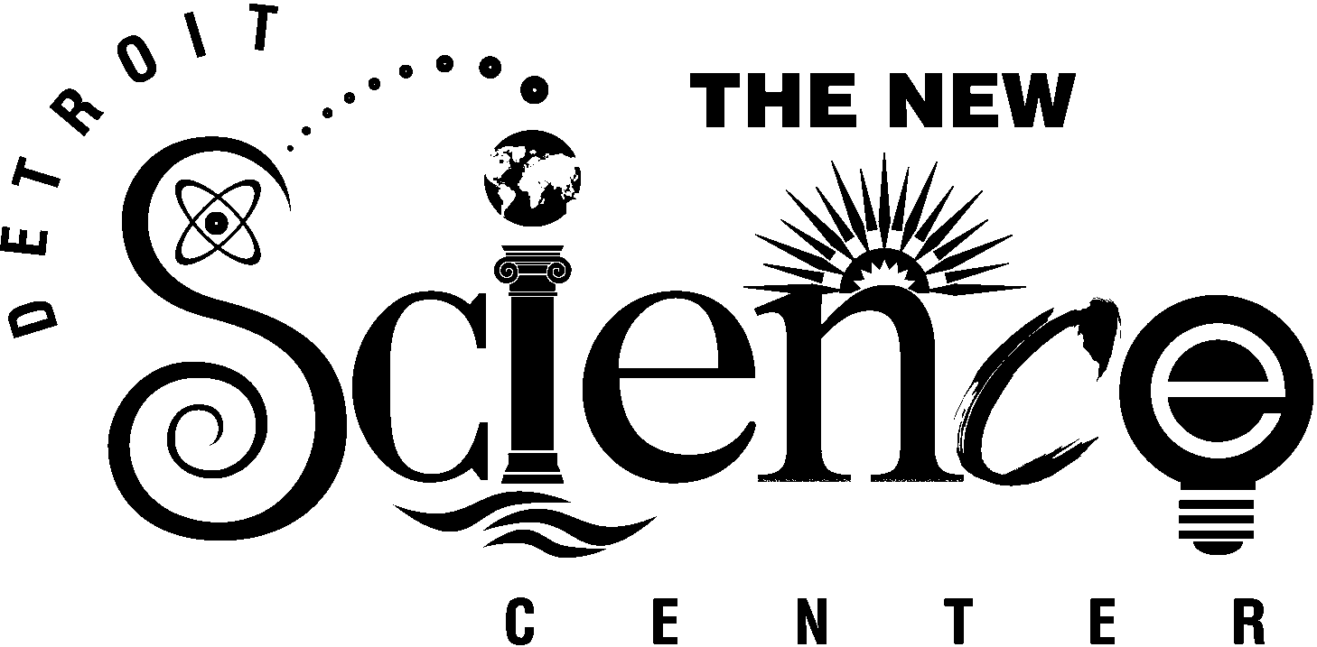
FOR IMMEDIATE RELEASE
Media Contacts:
Kelly Fulford
Public Relations Manager
313.577.8400 x430
313.832.1623 (fax)
kfulford@sciencedetroit.org

DTE Energy:
Amy Allor Lorie Kessler
313.235.9154 313.235.8807

DTE ENERGY MAKES “SPARK-TACULAR” CONTRIBUTION TO

THE NEW DETROIT SCIENCE CENTER

DETROIT, June 6, 2002 -- DTE Energy and The New Detroit Science Center announced the official debut of the DTE Energy Sparks Theater with a new program that includes shooting three-to-four-foot lightning bolts. Underwritten by a grant and in-kind support from the DTE Energy Foundation, the DTE Energy Sparks Theater will engage and enlighten thousands of children to the wonders of electricity and magnetism.

The announcement was made by Anthony F. Earley, Jr., chairman and CEO of DTE Energy, and Shawn M. Kahle, president and CEO of The New Detroit Science Center who were joined by more than 60 middle school students from Golightly Educational Center and Earhart Middle School in Detroit for an inaugural performance in the new theater.

“DTE Energy is extremely pleased to be partnering with The New Detroit Science Center to encourage a love of science, engineering and technology in all people, especially kids,” said Earley. “Through our new program partnership with the Detroit Science Center we hope to inspire and educate in an entertaining way.”

The DTE Energy Sparks Theater offers brilliant electric devices and demonstrations. The demonstrations show how electricity affects the world, and how electricity and magnetism interact with matter. Sparks Theater is contained in a Faraday cage, which keeps electromagnetic waves under control, to ensure the safety of demonstrations.

“The DTE Energy Sparks Theater is an integral part of the Science Center experience. Each area and program is carefully designed to allow children of all ages to observe and explore the fundamental principals of electricity and magnetism, energy conversion and the properties of matter,” said Kahle. “We greatly appreciate the generosity and support of DTE Energy in helping us create this incredible learning venue.”
- more -
- 2 -

The new DTE Energy Sparks Theatre program includes demonstrations of a large Tesla Coil that shoots three-to-four-foot lightning bolts, a large Van de Graff Generator that produces a “hair-raising” experience, a Climbing Arc (Jacob’s Ladder) that generates a spark between two wires and an Exploding Wire that uses 600 million watts of stored power to create an incredible display of light and sound.

In celebration of the partnership, DTE Energy hosted an employee day at the Science Center providing hundreds of employees and their families an opportunity to visit the Science Center and experience the new DTE Energy Sparks Theater. Also part of the celebration, DTE Energy hosted its annual ceremony and dinner at the Science Center for 52 students recognized for their achievements as part of the Metropolitan Detroit Science Fair. DTE Energy has been a sponsor of the Science Fair for the last 18 years. That competition draws hundreds of projects from all disciplines of science. Among those, DTE Energy selects the best student projects that focus on energy and the environment. The 52 winners were selected by a team of judges comprised of DTE Energy employees from various engineering backgrounds.

The DTE Energy Foundation continues the legacy of community involvement and support from the former Detroit Edison Foundation and MichCon Foundation following the merger of DTE Energy and MCN Energy. The DTE Energy Foundation directs its contributions and involvement to support initiatives dedicated to developing human and economic potential of the communities it serves. Grants are awarded under the foundation’s “LEAD” guidelines: leadership, education, environment, achievement, development and diversity in the DTE Energy service territory, which includes southeast, western and northern Michigan.

The New Detroit Science Center features 110,000 square feet of scientific exploration, including Michigan’s only IMAX® Dome Theatre; a Digital Dome Planetarium; the Ford Learning Resource Center; the DTE Energy Sparks Theater; the DaimlerChrysler Science Stage; an 8,700 square-foot Science Hall for traveling exhibits; five exhibit laboratories – General Motors Motion Laboratory, Dow Foundation Life Sciences Laboratory, Waves & Vibrations Laboratory, Matter & Energy Laboratory and SBC Ameritech Children’s Gallery; and a Special Events Lobby. In July 2001, the Science Center completed a $30 million renovation and expansion. It is projected to serve more than 500,000 visitors in its first year. For more information on The New Detroit Science Center please call 313-577-8400 or visit the website, www.detroitsciencecenter.org.

# # #

