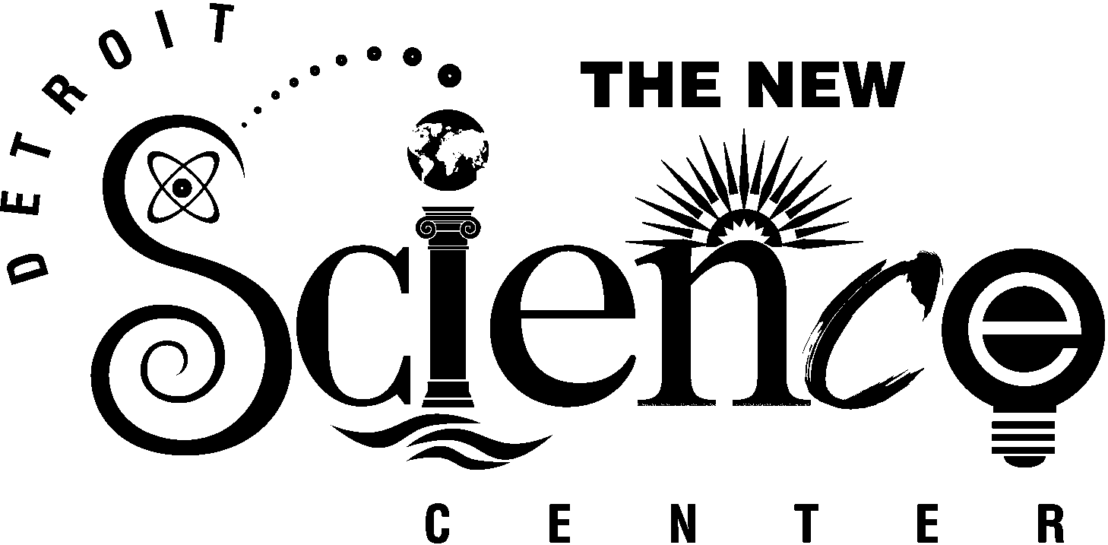

LIVELY LABORATORIES & UNCOMMONLY COOL CLASSROOMS

The GM Motion Laboratory features more than 30 interactive displays that demonstrate the principals of motion including simple machines, rotation, mechanical advantage, aerodynamic forces, pendulums and gyroscopes. Developed in partnership with the Society of Automotive Engineers (SAE), the laboratory takes on aspects of SAE’s A World in Motion curriculum. Experience the power of simple machines as you lift 1,000 pounds using the Giant Lever or sit in a pull-up seat and feel the effect of different pulley systems. Experiment with gears—essential ingredients in automotive engineering—in four gear walls. Power an engine in our Cranks-a-Lot exhibit or a 1,700-pound flywheel to store your energy and see how long it continues to turn. A 40-foot Foucault Pendulum demonstrates the rotation of the Earth. Learn about steam engines at the Workshop, which offers a 12-seat worktable and demonstration area, or watch the principles of science come to life on the DaimlerChrysler Science Stage, a 1,650-square-foot demonstration area where audience members can ride a hover car or alter their center of gravity.

The Herbert H. and Grace A. Dow Foundation Life Sciences Laboratory explains the wonders of nature with spectacular exhibits and interactive displays. Observe the similarities between urban and rainforest ecosystems by comparing the wildlife that inhabits these environments. Explore a two-story, simulated rainforest complete with an interactive waterfall that lets you alter the water flow. In the research hut, use microscopes to explore the world of the very small. Study the structure of plant and animal cells with a set of detailed models. Nearby, human anatomy is illuminated as you touch a button to light up a life-size anatomical model.

The Matter & Energy Laboratory provides insight into the fundamental principals of electricity and magnetism, energy conversion and the properties of matter. Tabletop exhibits encourage exploration of circuits, electrical loads and patterns created by magnetic fields. Power a light bulb with a hand-crank generator—then see how much less effort is required to light a fluorescent tube of the same intensity. Create electrical circuits at the circuit table and witness the effects of magnetic fields. Watch a six-foot vortex form in the Tornado Chamber and experiment with hydraulic pressure in the water column. Observe the power of buoyancy that causes a hot-air balloon to rise 30 feet to the ceiling above the seats of the DaimlerChrysler Science Stage, then look at it up close in the convection tank. Don’t miss the “spark-tacular” demonstrations in the DTE Energy Sparks Theater where static electricity will make your hair stand on end, four-foot lightning bolts leap from a Tesla Coil and wire explodes in a brilliant display as millions of volts pass through it.

Surf the phenomena of everyday light and sound in the Waves and Vibrations Laboratory. Explore the electromagnetic spectrum at interactive tabletop displays that investigate microwaves, radio waves, x-rays and visible light. Learn the difference between compression and transverse waves, experiment with the two-story “shive” wave device or adjust the speed of a spinning rope to create standing waves of different lengths. Discover how light reflects and how it is absorbed. Sound wave displays look at the science of pitch, amplitude and reflection. Transmit your image through a series of lenses to someone 16 feet away. Don’t miss the laser harp where everyone is a musician as they “play” on invisible beams of light. Light and sound are phenomena we encounter everyday. This distinctive lab helps you see them in a whole new light.

- more -
- 2 -

The SBC Ameritech Children’s Gallery features exhibits designed to meet the interests of kindergarten and pre-school aged children. Each area offers opportunities for children to develop social and motor skills through an interest in science as play. A highly tactile maze welcomes children to a world where they can creatively build their own spaces or affect pre-made environments as they aim fans at a flag field, crawl through honey comb cells or build with blocks. Everyday objects become boats and water movers in a water feature surrounded by aquariums and plants. A quiet area provides families with a space where children can work on computers and infants can receive special care. Children can create treasures to take home in the Make and Take area, a space designed as a “science through art” studio. A shadow room encourages visitors to experiment with shadows using puppets and other objects like flashlights, long streamers and dramatic play materials.

The Ford Learning Resource Center welcomes minds in motion with five unique learning classrooms that are out of this world. Classroom programs offer hands-on, inquiry-based learning, professional development opportunities, educational resources and classroom curriculum enhancement. Classrooms include a Space Sciences classroom, which resembles the interior of a space ship and includes a wraparound mural to add to the illusion of flying in outer space; an Earth Sciences classroom that features an interactive, wraparound mural displaying North America's six biomes: coral reef, temperate forest, wetland, grassland, mountain and desert; a Life Sciences classroom that allows students to experience the role of an amateur scientist in a 19th-Century era laboratory, combining classic laboratory equipment with current technology; a Physical Sciences classroom where students can discover the worlds of light, sound, magnetism, electricity, motion and force, and an Applied Sciences classroom that houses a computer lab to allow visitors to design, engineer and build their vision of the future.

# # #

