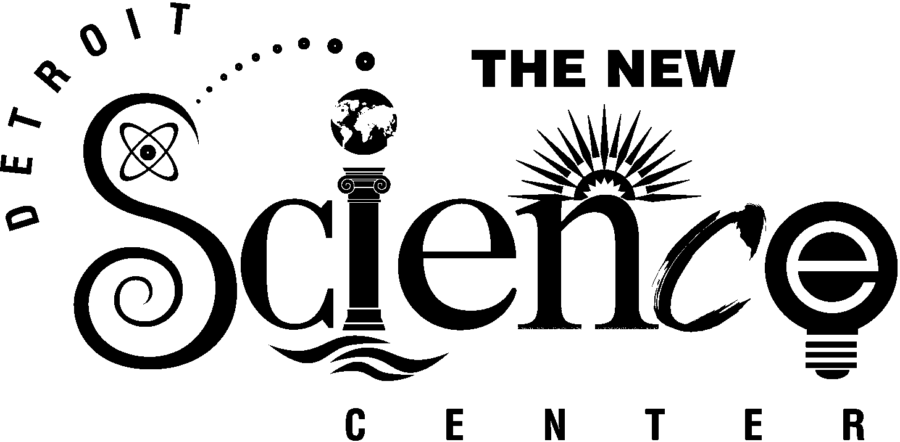
FOR IMMEDIATE RELEASE
Media Contacts:
Kelly Fulford
Director of Public Relations & Marketing
313.577.8400 x430
kfulford@sciencedetroit.org
Matt Friedman
248.855.6777

THE NEW DETROIT SCIENCE CENTER ANNOUNCES PREVIEW EVENTS FOR
TITANIC: THE ARTIFACT EXHIBIT

DETROIT, Jan. 22, 2003 -- The New Detroit Science Center is launching Titanic: The Artifact Exhibit in style with a series of special events, including a Captain’s Celebration fundraiser, an All Aboard: Members-Only Event, a Hospitality & Tourism Industry Open House and an Educators Week Aboard Titanic.

Titanic: The Artifact Exhibit is the world’s only touring exhibition of actual artifacts from Titanic’s wreck site, two-and-a-half miles below the surface of the North Atlantic. The exhibit makes its Michigan debut Feb. 8, 2003 at The New Detroit Science Center and will be open through Sept. 7, 2003.

Captain’s Celebration – Wednesday, February 5
Captain’s Celebration guests will be the very first to experience the grandeur of Titanic on Wednesday, Feb. 5, from 6:00 p.m. to 10:00 p.m. at The New Detroit Science Center. The exhibit will open to guests with the Captain’s toast at 6:45 p.m. Guests also will have the opportunity to experience Titanica in the IMAX® Dome Theatre and Night of the Titanic - The Science of the Sinking in the Digital Dome Planetarium while mingling with “authentic” Titanic passengers and crew and listening to period music.

Tickets for the Captain’s Celebration include:
- $1,500 Promenade Deck: Reservations for eight plus admission to the exclusive Captain’s Reception* in the White Star Lounge and Captain’s Keepsake

- $750 Parlor Deck: Reservations for four plus admission to the exclusive Captain’s Reception* in the White Star Lounge and Sailor’s Souvenir

- $175 Upper Deck: Reservations for one plus admission to the exclusive Captain’s Reception* in the White Star Lounge

- $125 Passenger: Reservation for one
- more -
- 2 -

*The Captain’s Reception in the White Star Lounge offers a selection of fine spirits and elixirs and Captain’s fare. RSVP by Jan. 28, 2003 to Elizabeth Chilton, 313.577.8400, ext. 431. This event benefits programming at The New Detroit Science Center.

All Aboard: Members Only! Event – Friday, February 7
The All Aboard Members-Only Event will be held on Friday, Feb. 7 from 3 p.m. – 8 p.m. During this event, Science Center members will have an exclusive opportunity to see Titanic: The Artifact Exhibit, Titanica in the IMAX® Dome Theatre and Night of the Titanic - The Science of the Sinking in the Digital Dome Planetarium. Admission is $6.95 for adult premium members and $4.95 for child premium members to see the exhibit and theater shows. Adult admission for regular members is $6.95 for the exhibit and an additional $2 for each theater show. Child member admission is $4.95 for the exhibit and an additional $2 for each theater show. Advance exhibit tickets are available through Ticketmaster at 248.645.6666 or www.ticketmaster.com through Jan. 28. Any exhibit tickets not sold in advance will be available for members to purchase at the Science Center. Theater tickets only will be available at the Science Center on Feb. 7. For information on becoming a member of The New Detroit Science Center, please call 313.577.8400, ext. 433, or e-mail membership@sciencedetroit.org.

Titanic Hospitality & Tourism Industry Open House – Thursday, February 13
Explore the possibilities of hosting your next great event at The New Detroit Science Center. Titanic: The Artifact Exhibit will be open to meetings and events planners, members of the tourism and hospitality industry, and related professionals on Thursday, Feb. 13, from 5 p.m. – 8 p.m.

Guests will have the opportunity to sample cuisine from the Science Center’s preferred caterers, including Crank’s Catering, Edibles Rex Catering, Forte Belanger Catering, Jackson’s Five Star Catering, Merchant’s Fine Wine, Opus One and the Rattlesnake Club. Guests also will have the opportunity to discover décor and special events planning services from Star Trax Corporate Events and experience Titanica in the IMAX® Dome Theatre and Night of the Titanic - The Science of the Sinking in the Digital Dome Planetarium. To register, go to www.startraxevents.com. Registration and confirmation number required for admission.

Educator Week Aboard Titanic – Feb. 24-28
Educators can enjoy a special discounted rate of only $6.95 per adult during Educator Week Aboard Titanic, Feb. 24-28 from 9 a.m. – 5 p.m. Educators can experience new classroom programs in the Ford Learning Resource Center and a spectacular new show on the DaimlerChrysler Science Stage.
- more -

- 3 -
Educators can experience the IMAX® Dome film Titanica or the Digital Dome Planetarium show Night of the Titanic for an additional $2.00, or both shows for $4.00. No advance reservations are required for Educator Week, although proof of educator status is required for the special discount.

For more information on Titanic special events at The New Detroit Science Center, please call 313.577.8400 or go to www.detroitsciencecenter.org.

The New Detroit Science Center features 110,000 square feet of scientific exploration, including Michigan’s only IMAX® Dome Theatre; a Digital Dome Planetarium; the Ford Learning Resource Center; the DTE Energy Sparks Theater; the DaimlerChrysler Science Stage; an 8,700 square-foot Science Hall for traveling exhibits; five exhibit laboratories – General Motors Motion Laboratory, Dow Foundation Life Sciences Laboratory, Waves & Vibrations Laboratory, Matter & Energy Laboratory and SBC Ameritech Children’s Gallery; and a Special Events Lobby. In July 2001, the Science Center completed a $30 million renovation and expansion. It served more than 471,000 visitors in its first year. For more information on The New Detroit Science Center please call 313-577-8400 or visit the website, www.detroitsciencecenter.org.

###

