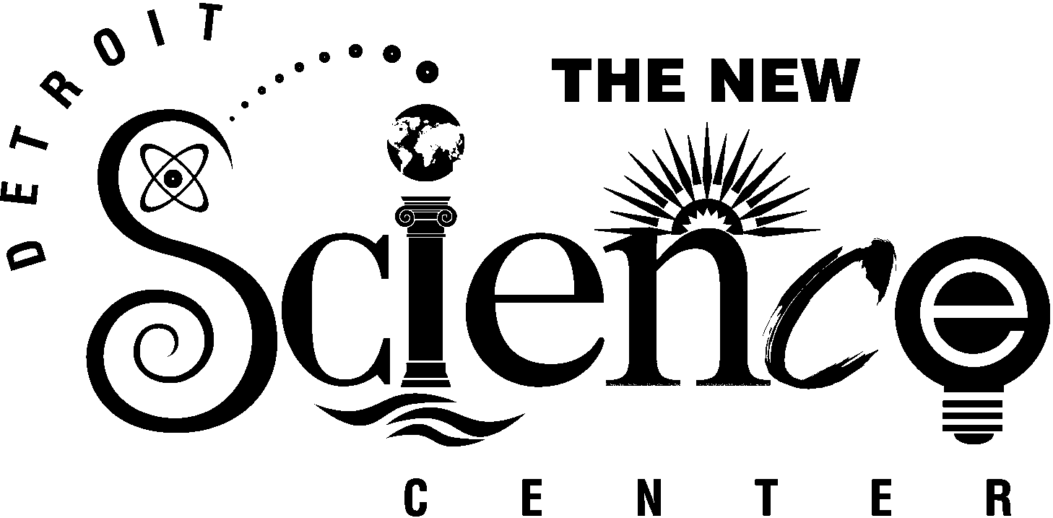

FOR IMMEDIATE RELEASE
Media Contacts:
Kelly Fulford
The New Detroit Science Center
313.577.8400 x430
Matt Friedman
Marx Layne
248.855.6777



Exhibit of Titanic Proportions Docks At The New Detroit Science Center

February 8 - September 7, 2003

DETROIT, Feb. 5, 2002 -- On a calm, clear night in April 1912, the “unsinkable” sank in the freezing cold water of the North Atlantic and a legend was born. Pieces of personal histories and hundreds of artifacts recovered from the wreck site tell the tale in Titanic: The Artifact Exhibit, a blockbuster traveling exhibit to be on display at The New Detroit Science Center Feb. 8 – Sept. 7, 2003.

Titanic, the ship of dreams, was conceived in 1907 and met with disaster in 1912. It was lauded as the greatest ship in history. On board were titans of commerce, artists, leaders of countries, immigrant dreamers, mothers, fathers, sons and daughters. The story of Titanic has been told and retold, but never more poignantly and passionately than by the artifacts presented in this exhibition. Painstakingly recovered from the debris field surrounding the wreck and artfully conserved, these three-dimensional objects, more than words or images, represent the vessel and the 2,228 souls who journeyed with her into history.

Spanning more than 9,000 square feet, the exhibit will take visitors on a chronological journey through the life of the Titanic, from the building of the legend, which took 1,500 men more than three years to complete, to life on board. Authentically recreated first- and third-class rooms will be featured with furnishings made by original manufacturers. Visitors also will glimpse a typical day aboard the great

- more -

- 2 -

vessel by strolling through the Veranda Café, one of the dining areas on the ship. In “The Striking” gallery, guests will touch an “iceberg” and feel for themselves what it must have been like in the water most passengers on the ill-fated vessel found themselves in that April night. Lastly, exhibit guests will see the science, technology and artistry it takes to recover these items from 2.5 miles below the ocean’s surface and to preserve them for future generations.

"Clear Channel Exhibitions, through our association with The New Detroit Science Center, is proud to bring Titanic: The Artifact Exhibit to Detroit. We are excited about the opportunity to provide an incredible family entertainment experience of the highest quality," said Stacy F. King, President and Chief Operating Officer, Clear Channel Exhibitions.

“The New Detroit Science Center is pleased to be able to share the history of Titanic, the personal stories of her passengers, the artistry of the galleries and the science used to recover and preserve the hundreds of artifacts that will be on display here with our visitors from throughout the region,” said Shawn M. Kahle, President & CEO of The New Detroit Science Center.

Science Center hours starting Feb. 8, 2003 will be Monday - Friday, 9 a.m. to 5 p.m., Saturday - Sunday, 10:30 a.m. – 6 p.m. Advance tickets are available from Ticketmaster at 248-645-6666, online at www.ticketmaster.com or at a Ticketmaster outlet. Tickets to Titanic: The Artifact Exhibit are $16.95 for adults, $13.95 for seniors over age 60 and $11.95 for children 2-12. Tickets include general admission to the Science Center.

Science Center visitors will be able to continue their voyage with the IMAX® film Titanica, showing in the IMAX® Dome Theatre, and explore the reasons this ‘unsinkable’ ship met its end in Night of the Titanic: The Science of the Sinking, the Digital Dome Planetarium show, both showing Feb. 8 – Sept. 7, 2003. Titanica is a fascinating non-fiction drama that tells the story of the 1991 expedition to the wreck of the Titanic. Night of the Titanic: The Science of the Sinking recreates the environment in the North Atlantic off the Newfoundland Coast on April 14, 1912, down to the exact star field that passengers of the Titanic looked upon that fateful night. Visitors may add the IMAX® film Titanica or the Digital Dome Planetarium show Night of the Titanic for an additional $4 or both shows for an additional $6. Exhibit admission for children under age 2 is free.

- more -
- 3 -

Science Center members will pay only $6.95 for adults or $4.95 for children 2-12 to see the exhibit. General admission to the Science Center is included with membership. Members may add the IMAX® film Titanica or the Digital Dome Planetarium show Night of the Titanic for an additional $2, or both shows for an additional $4. Exhibit admission for children under age 2 is free. Premium members pay only $6.95 for adults or $4.95 for children 2-12 to see the exhibit and theater shows.

Special rates apply for schools and groups of 15 or more. Please call 313-577-8440, Option 5, for group information.

The New Detroit Science Center features 110,000 square feet of scientific exploration, including Michigan’s only IMAX® Dome Theatre; a Digital Dome Planetarium; the Ford Learning Resource Center; the DTE Energy Sparks Theater; the DaimlerChrysler Science Stage; an 8,700 square-foot Science Hall for traveling exhibits; five exhibit laboratories – General Motors Motion Laboratory, Dow Foundation Life Sciences Laboratory, Waves & Vibrations Laboratory, Matter & Energy Laboratory and SBC Ameritech Children’s Gallery; and a Special Events Lobby. In July 2001, the Science Center completed a $30 million renovation and expansion. It served more than 471,000 visitors in its first year. For more information on The New Detroit Science Center please call 313-577-8400 or visit the website, www.detroitsciencecenter.org.

Titanic: The Artifact Exhibit is produced by Clear Channel Exhibitions in association with R.M.S. Titanic, Inc. Clear Channel Exhibitions, a division of Clear Channel Entertainment, is based in San Antonio, Texas. CCE is a world leader in providing high quality, state-of-the-art educational family experiences, and produces exhibits in collaboration with more than 200 leading museums and research institutions.

# # #

